**Assignment : OSPF**

**Computer Networking**

**Tanmay Dureja (td1391)**

1. Screenshot configurations of R1, R2, R3, and R4.

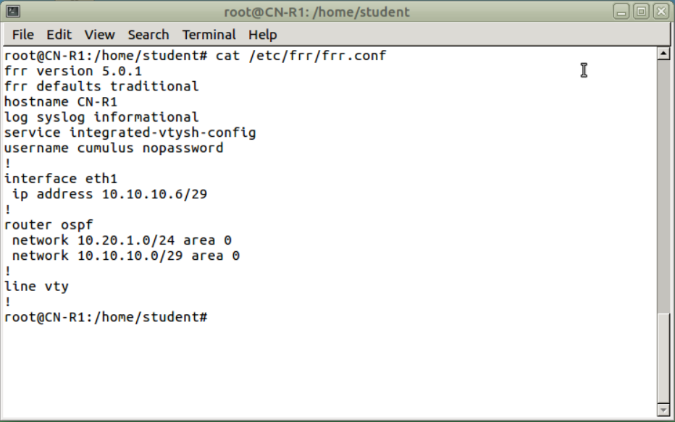

Capture 1 Config File for R1

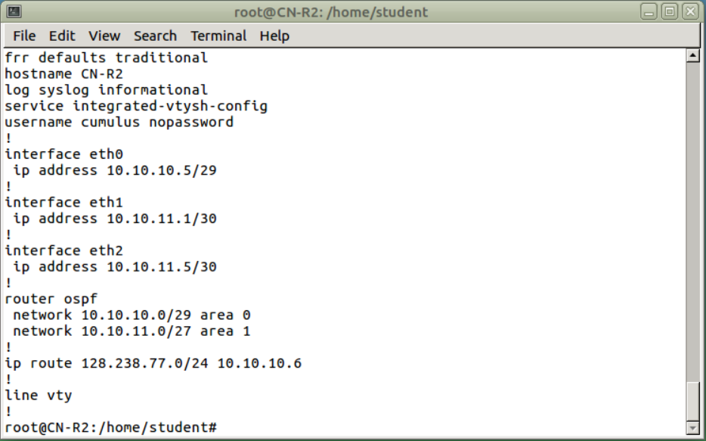

Capture 2 Config File for R2

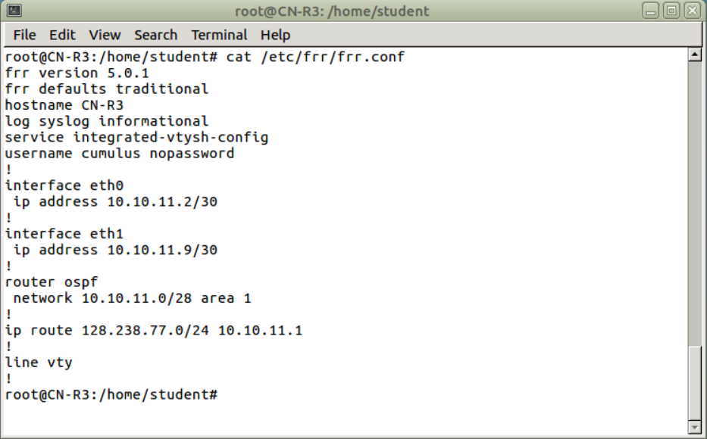

Capture 3 Config File for R3

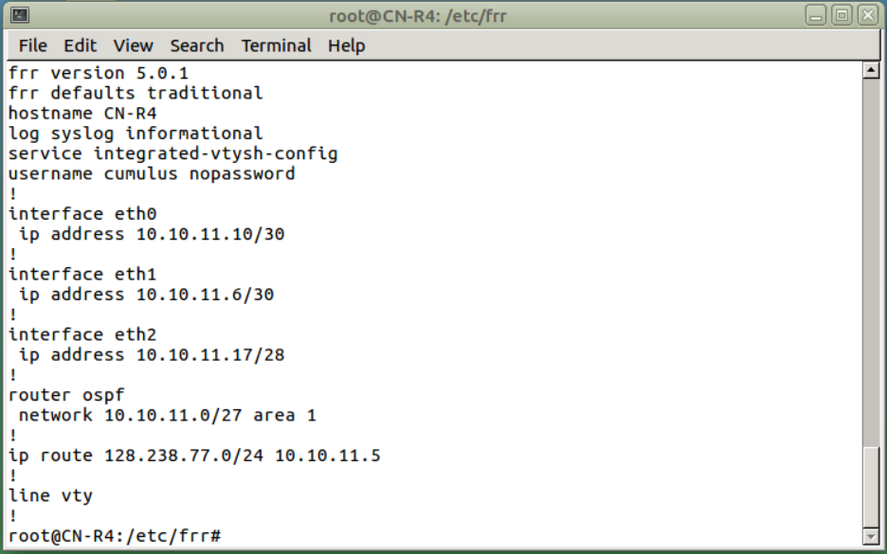

Capture 4 Config File for R4

1. ICMP results and Wireshark screenshots on R1.

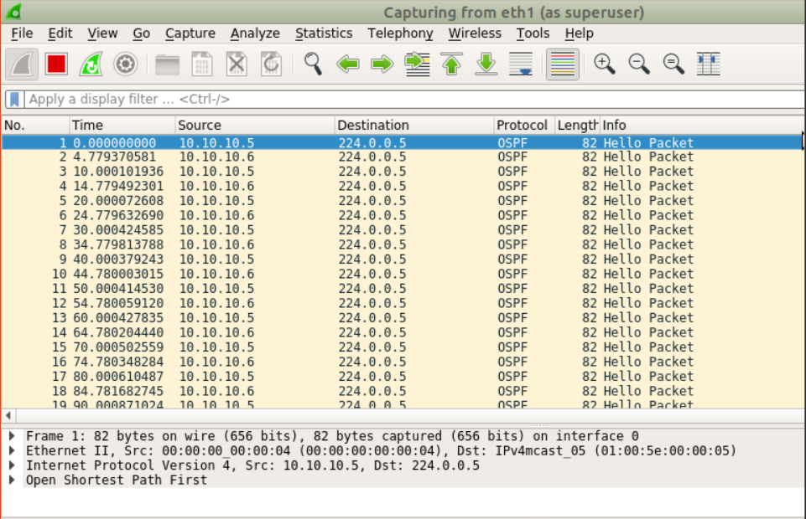

Capture 5

**R2 to R1**

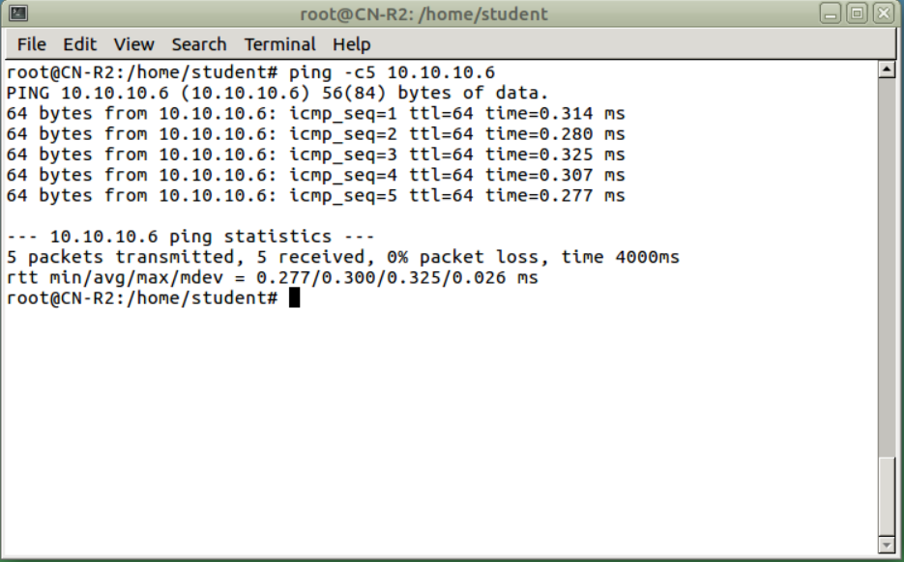

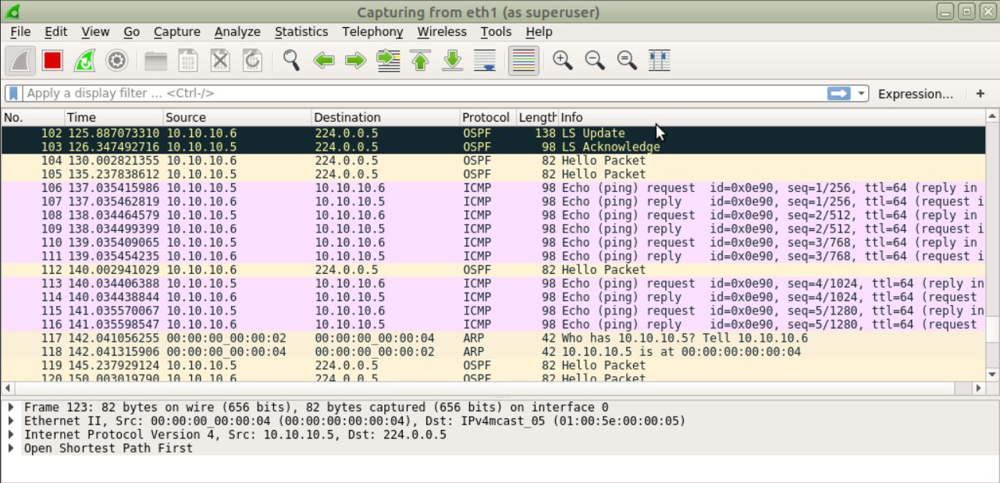

Capture 6 Ping R2 to R1

**R3 to R1**

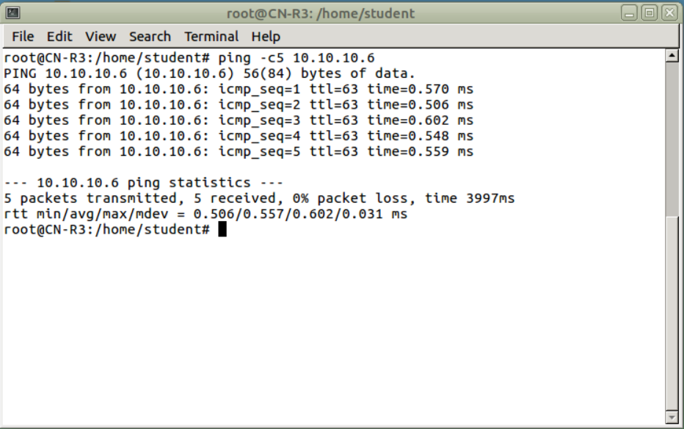

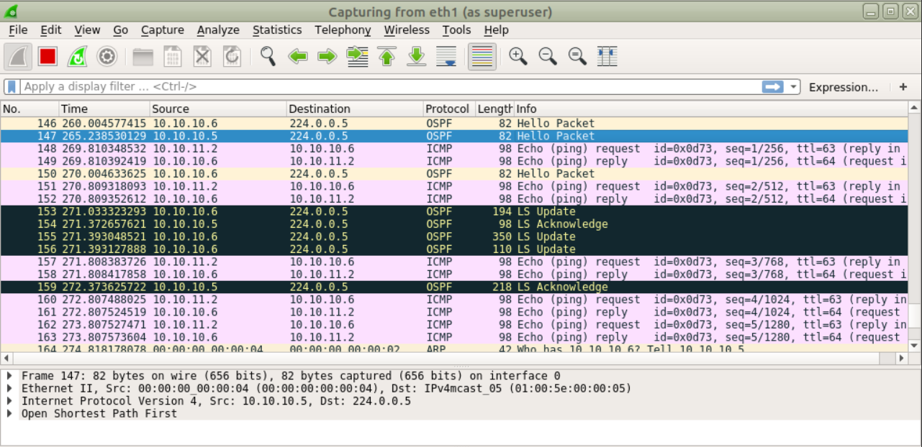

Capture 7 Ping R3 to R1

**R4 to R1**

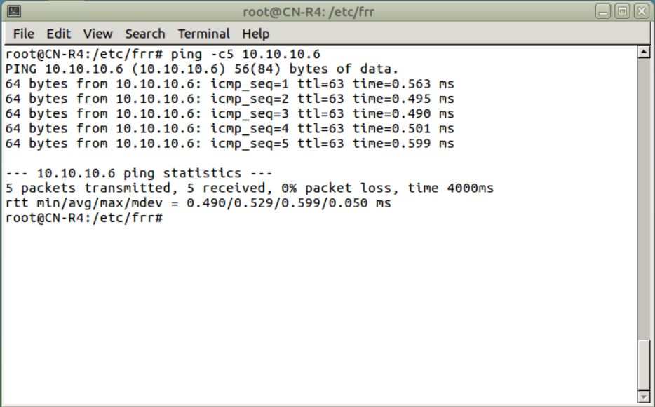

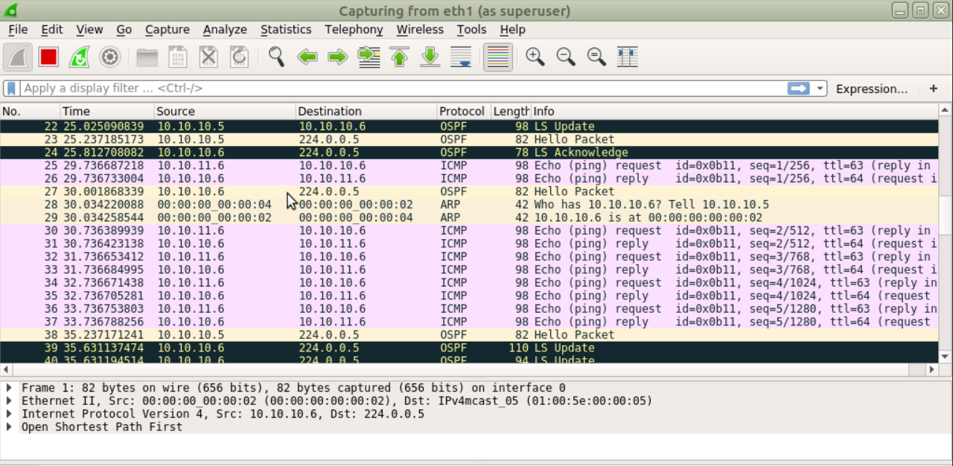

Capture 8 Ping R4 to R1

1. Screenshots depicting successful ping requests to 128.238.77.36 from R1, R2, R3, and R4

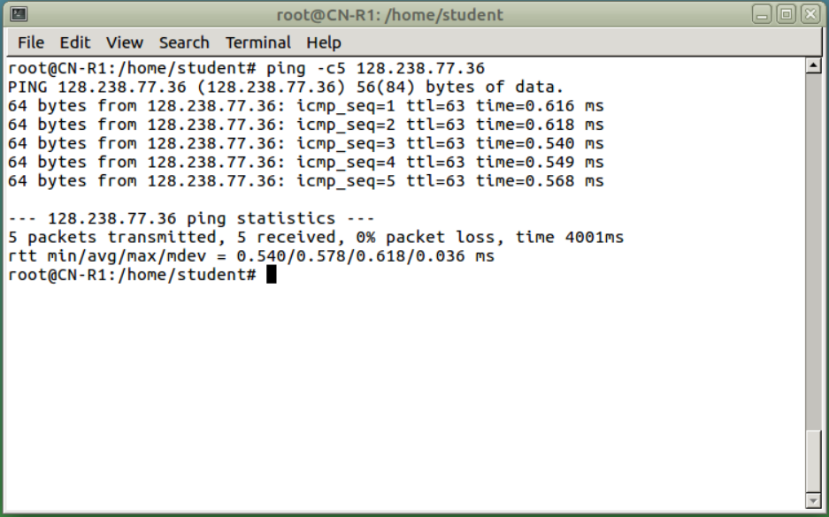

Capture 9 Ping 128.238.77.36 from R1

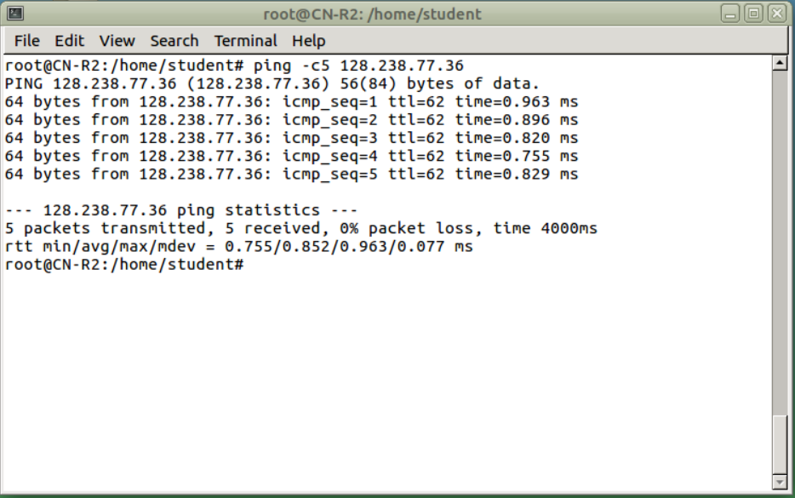

Capture 10 Ping 128.238.77.36 from R2

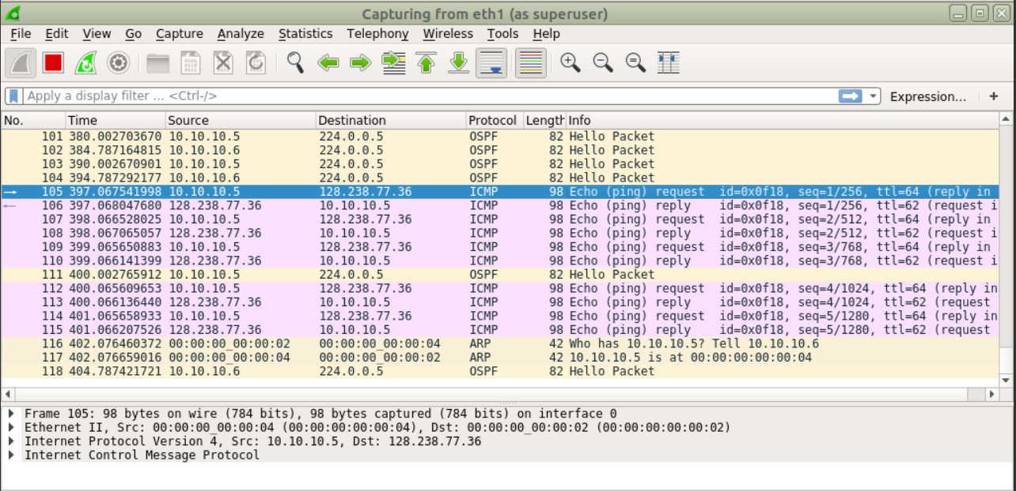

Capture 11 Wireshark Ping 128.238.77.36 from R2

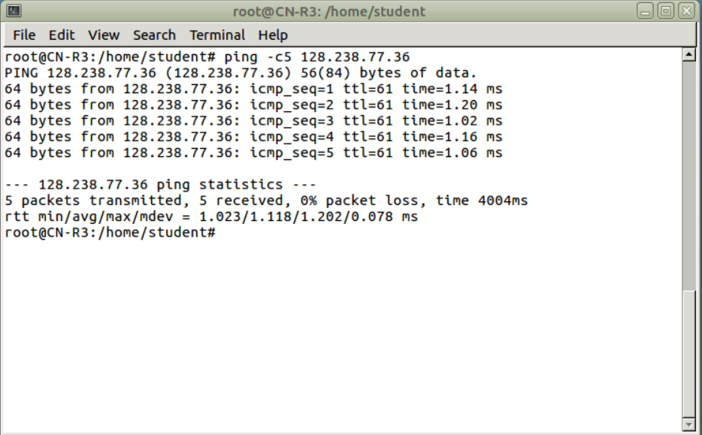

Capture 12 Ping 128.238.77.36 from R3

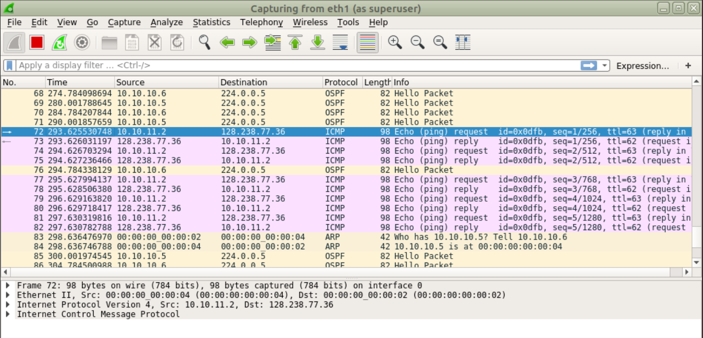

Capture 13 Wireshark Ping 128.238.77.36 from R3

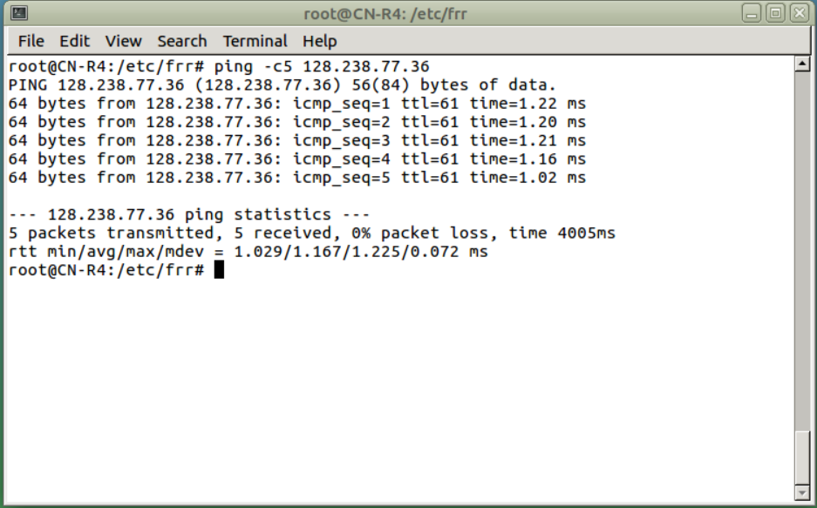

Capture 14 Ping 128.238.77.36 from R4

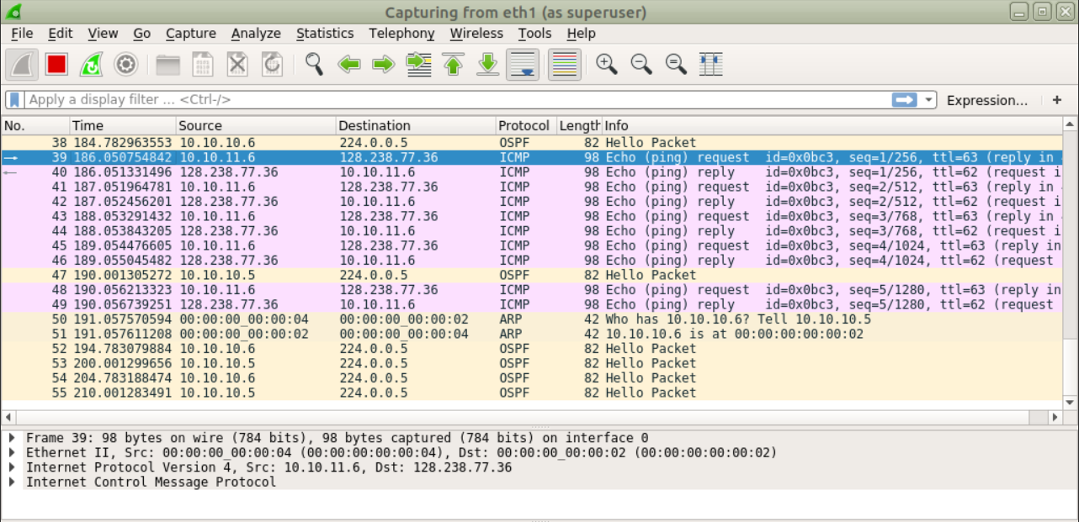

Capture 15 Wireshark Ping 128.238.77.36 from R4